Institutional Aid Renewable Policy

This institutional aid renewable policy is made effective the date last signed below by and between Rochester Christian University, of 800 West Avon Road, Rochester Hills, Michigan 48307, and the Recipient whose name is signed below.

The Parties Agree As Follows:

Renewable Requirement: Students receiving institutional aid will be required to meet a minimum of a 2.0 Cumulative GPA (CGPA). The first semester a student does not meet the requirement, they will be placed on Academic/Financial Aid Warning. They will be eligible for their full amount of scholarship(s) while on Academic/Financial Aid Warning. The second semester a student does not meet the requirement, they will be placed on Academic/Financial Aid Suspension. 100% of the student’s institutional aid will be removed until the student meets the 2.0 CGPA. If the student appeals and is approved for Academic/Financial Aid Probation on an Academic Plan, the student may receive institutional aid if they are meeting all requirements for the Academic Plan. For additional information on academic requirements and financial aid eligibility, please refer to the Satisfactory Academic Progress (SAP) Policy in the course catalog. The Rochester Christian University course catalog may be found on the RCU website at rochesteru.edu/academics/course-catalog/.

Students must be enrolled full-time (minimum of 12 semester hours) to be eligible for institutional aid. For additional information on institutional aid, please refer to the current course catalog and the RCU website at rochesteru.edu/admissions/undergraduate-admissions/scholarship-opportunities/. Policy is located at Admissions>Financial Aid>Additional Resources >Institutional Aid Renewable Policy. Freshman Trustee Scholarship renewal CGPA is 3.50.

Initial packaging criteria and special renewal GPA requirements:
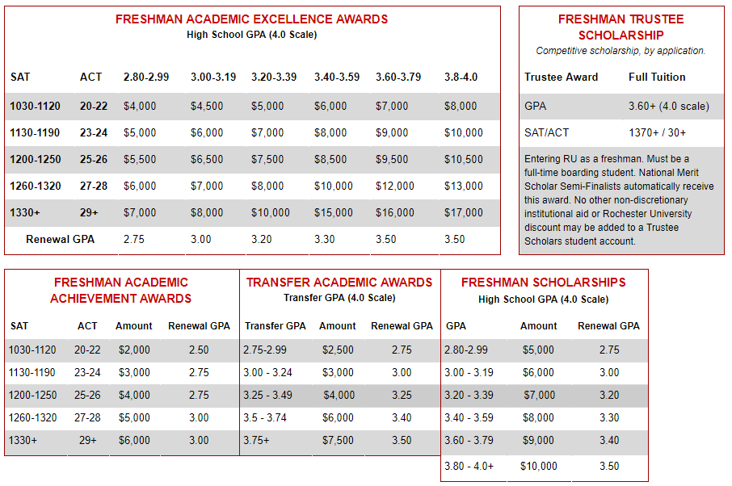
I, _______________________ understand the renewable requirement(s) for all institutional aid awarded to me for this award year and all future award years I attend Rochester Christian University. I further understand financial aid eligibility as it relates to Satisfactory Academic Progress (SAP) Policy at RCU.
First semester in attendance at Rochester Christian University: _______________

Student Financial Services Adviser

Signed: _____________________________ Date: ___________

RCU Scholarship Recipient (Student) Parent or Guardian (if recipient is under the age of 18)

Signed: ______________________________ Date: ___________ Signed: ______________________________ Date: ________________

Printed: ______________________________ Printed: ______________________________ Relationship: __________

