Entrance Counseling and Master Promissory Note
What you will need: verified username and password (FSA ID) to sign the forms, your driver’s license, Social Security Number and 2 references (names, addresses and phone numbers). One reference should be a parent. You need to have known both references for at least three years. Both references must reside in the USA. Students must FIRST complete the Entrance Counseling and THEN go on to the Master Promissory Note (MPN).
Entrance Counseling
- Log on to studentaid.gov – the updated official federal student aid website!
- Click on “In School” – “I’m in the process of earning a degree or certificate”
- Click on “Complete Loan Entrance Counseling”
- Click on “I am an Undergraduate Student”
- Click on the START button
- Under “Notify a School,” select ROCHESTER CHRISTIAN UNIVERSITY (School Code G02288)
- Click on the CONTINUE button
- You may add loan amounts you think you’ll owe, or you can use the prepopulated figures
- Answers are always on the page and you can print and download a summary of the counseling information
- Complete the questions until you come to the confirmation page and click “Submit”
- Our office will receive automatic confirmation when completed
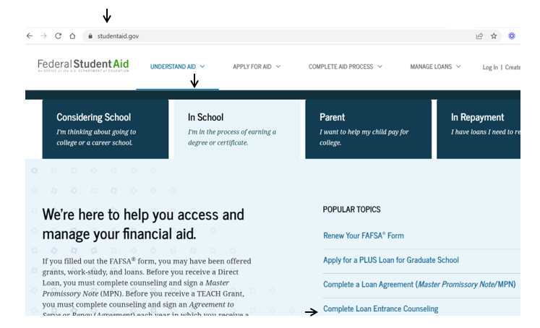

Master Promissory Note (MPN)
- Log on to studentaid.gov – the updated official federal student aid website!
- Click on “In School” – “I’m in the process of earning a degree or certificate”
- Click on “Complete a Loan Agreement (Master Promissory Note)”
- Click “Start” under “I’m an Undergraduate Student”
- Enter Borrower Information
- Under “School Information,” select ROCHESTER CHRISTIAN UNIVERSITY (School Code G02288)
- Click on the CONTINUE button
- Enter the requested information until you come to the confirmation page and “Submit”
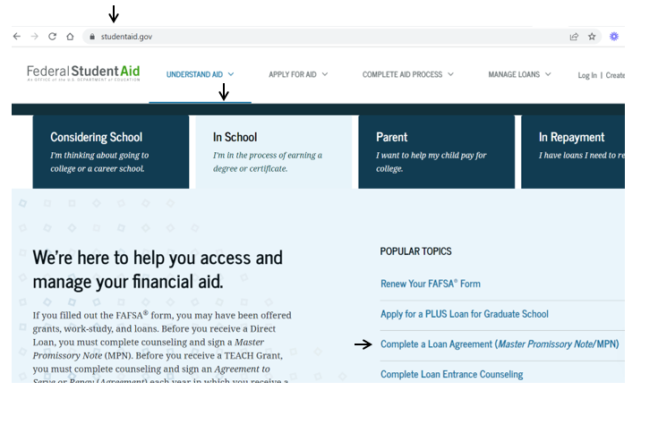
- Our office will receive automatic confirmation when completed

